

**A.M.A.L. DEGREE COLLEGE, Anakapalle** 

# Project submitted by:

Team leader : CHINNI RAMADEVI

Team member:DHULI USHA

Team member:PALIVELA YESWANTH KUMAR

Team member:pAMU MANIKANTA

# **CERTIFICATE**

*This is to certify that* ***Mrs.CHINNI RAMADEVI*** *Reg. No****:-720120105142*** *has completed her internship project (6thsemester) in APSCHE (SmartBridge Long-Term Virtual internship program) on* ***“SOFTWARE TESTING AUTOMATION****” under my supervision as a part partial fulfillment of the requirement for the Degree in the stream of B.Sc. (C.B.Z),A.M.A.L. College, Anakapalle.*

**DECLARATION**

I **Mrs. CHINNI RAMADEVI** a student of A.M.A.L College Anakapalle Reg. No**:- 720120105142** of the Department of B.sc(C.B.Z) here by declare that I have completed the Manadatory internship project on **“SOFTWARE TESTING AUTOMATION”** under the guidance of Dr.P.Sowjanya Department of ZOOLOGY in A.M.A.L. College.

nopCommerce is the best open-source eCommerce shopping cart solution. nopCommerce is free, and it is the most popular ASP.NET eCommerce platform. The first nopCommerce version was released in 2008. At that time there were no free and open-source shopping carts that would not impose the limitations on business processes and flow hence the essential goal for nopCommerce was to fix that.

The high quality of the product and its constant development led to creating the global nopCommerce community of over 250,000 members. The philosophy of the open-source product allows us to receive the contribution of developers and businesses from around the world. That helps us to grow faster and meet the highest security and technology standards.

n

o

p

C

o

m

m

e

r

c

e

H

O

M

E

P

A

G

E

~~:~~

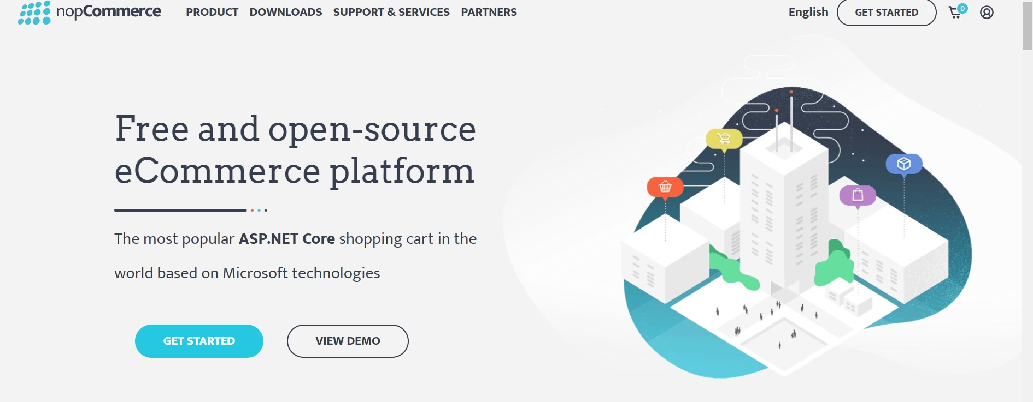

L

i

n

k

:

h

t

t

p

s

:

/

/

w

w

w

.

n

o

p

c

o

m

m

e

r

c

e

.

c

o

m

/

e

n

* User can user ecommerce platform
* User can register once and continue seeing ecommerce business maintenance
* User can login as admin & front-end/user resource and monitor the business
* User can also configure dashboard all setup related to ecommerce business

We have different modules in this all the modules are listedbelow,

* PRODUCT
  1. Store demo

○ Showcase

○ Features

○ Why for developers

○ Why for store owners

○ Industries

* DOWNLOADS
  1. Download nopCommerce

○ Marketplace

○ Translations

○ Copyright removal key

○ Mobile application

○ Web API

* SUPPORT&SERVICES
  1. Training

○ Documentation

○ Community forums

○ Premium support services

○ Request a quote

○ Contact us

* PARTNERS
* CHANGE LANGUAGE
* GET STARTED
* CART
* ACCOUNT
  1. Log in

○ Register

* GET STARTED ● VIEW DEMO

## 

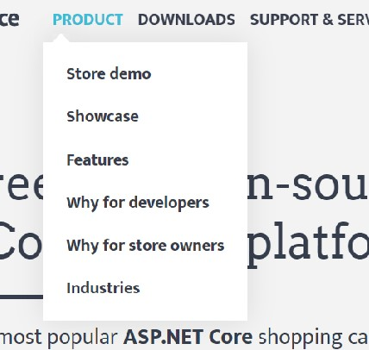

Link: https://www.nopcommerce.com/en

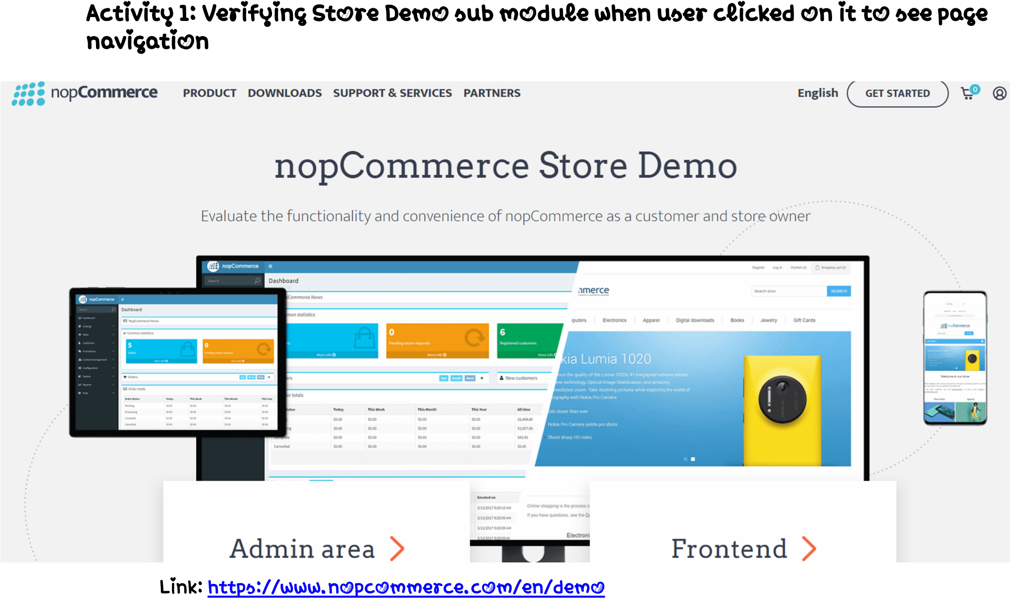

Verifying various text available on the screen to make sure all data is represented correct and verify Admin area, Frontend links

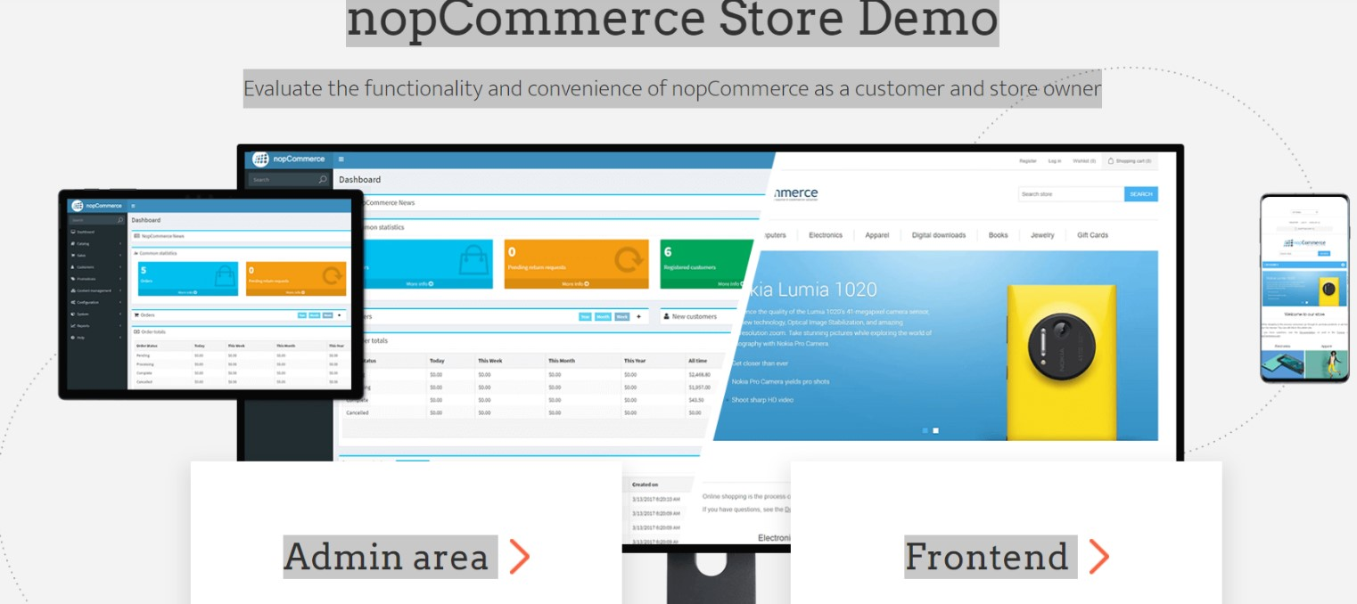

Link: https://www.nopcommerce.com/en/demo

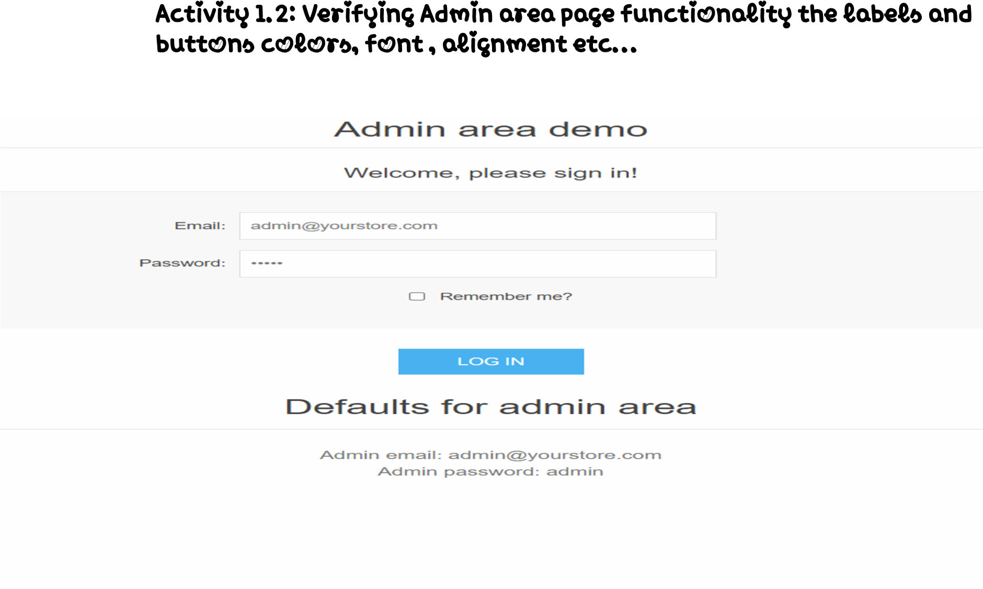

Link: https://admin-demo.nopcommerce.com/login?ReturnUrl=%2Fadmin%2F

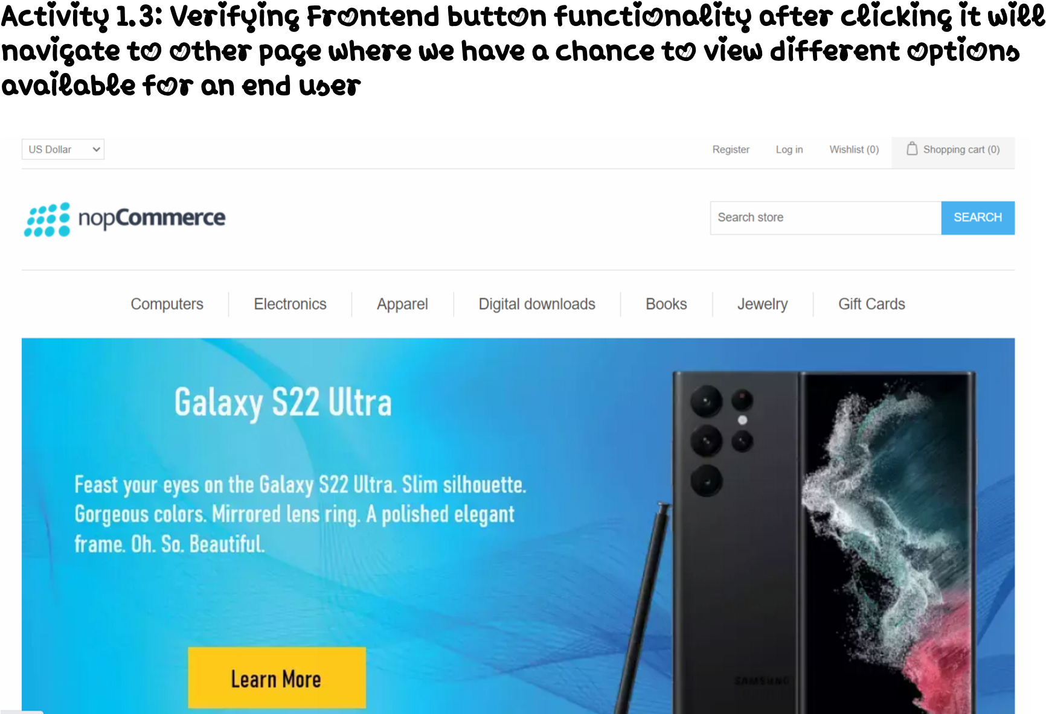

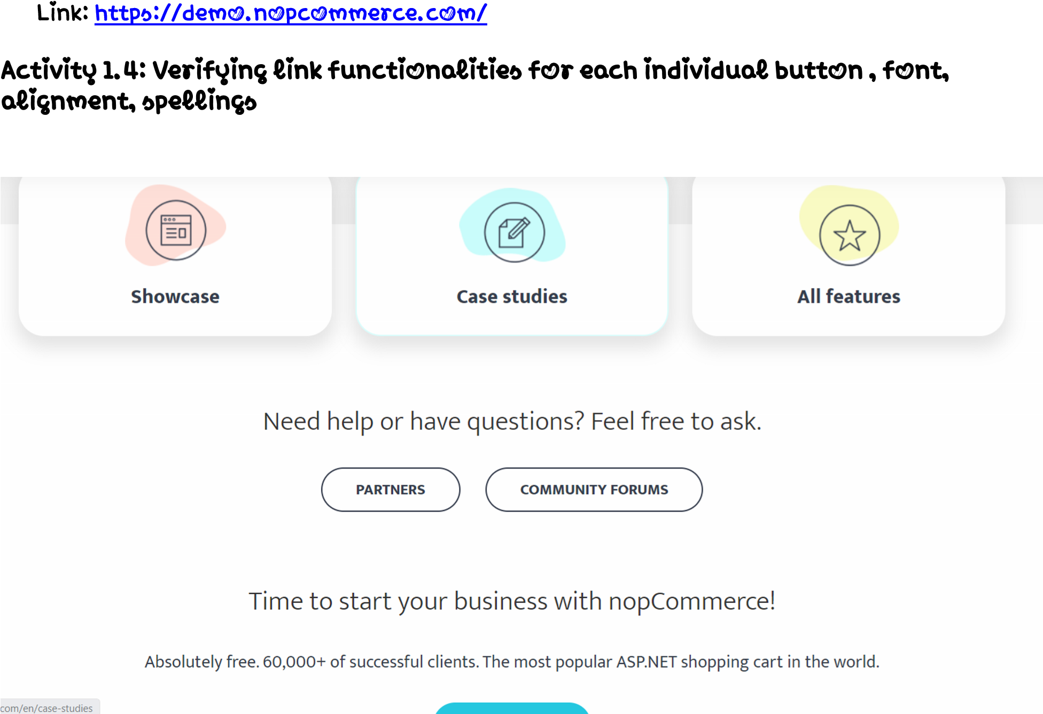

Link: https://www.nopcommerce.com/en/demo

Verifying each and every button, links functionality, upon clicking each link is it navigating to desired links are not.

In simple words, when a user clicks on sub module links it has to navigate to desired link and show the desired pages accordingly.

DOWNLOADS section for various options with Download nopCommerce, Marketplace, Translations,

Copyright removal key, Mobile application, Web API

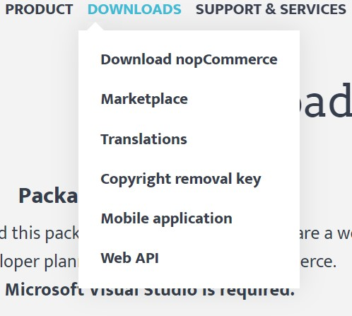

Link: <https://www.nopcommerce.com/en/de>



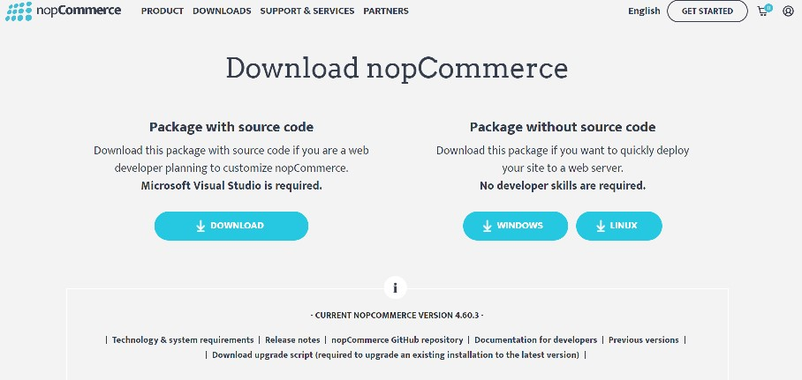

Link: https://www.nopcommerce.com/en/download-nopcommerce

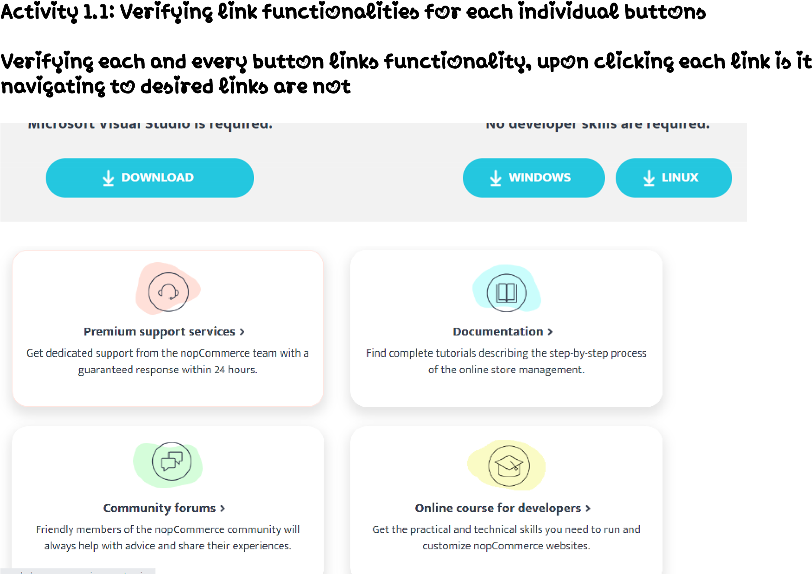

Link: https://www.nopcommerce.com/en/download-nopcommerce

In simple words, when a user clicks on sub module links it has to navigate to desired link and show the desired pages accor*di*ng

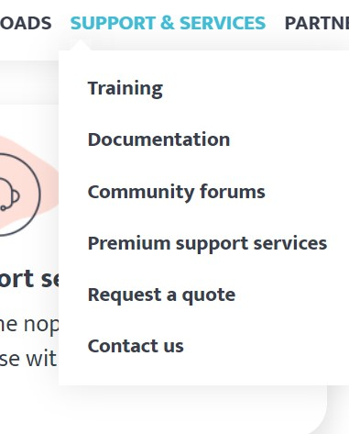

L

i

n

k

:

h

t

t

p

s

:

/

/

w

w

w

.

n

o

p

c

o

m

m

e

r

c

e

.

c

o

m

/

e

n

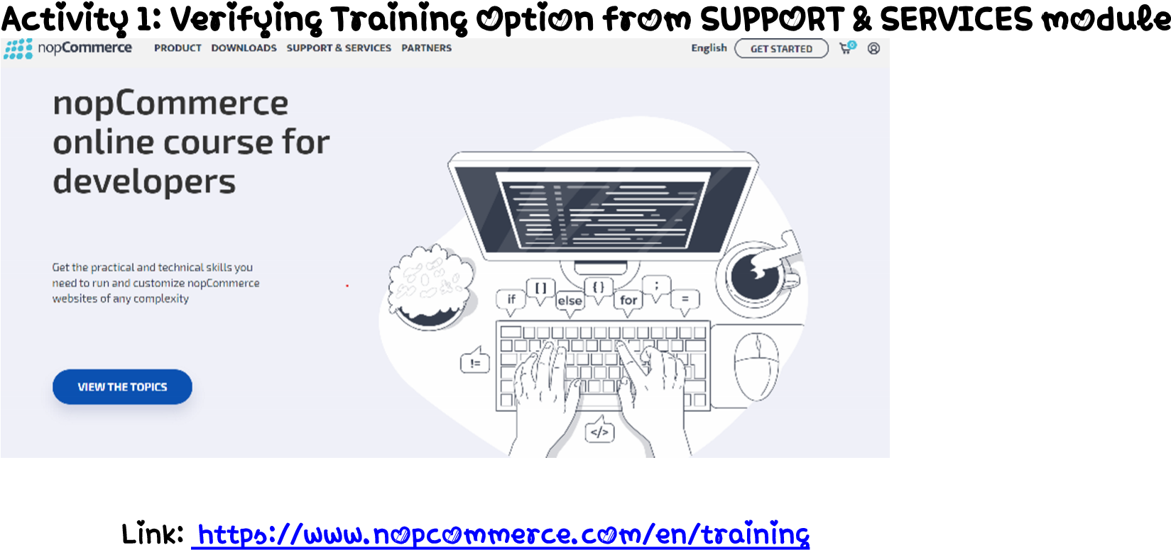

Verifying each and every button links functionality, upon clicking each link is it navigating to desired links are not.



Link: <https://www.nopcommerce.com/en/training>

In simple words, when a user clicks on sub module links it has to navigate to desired link and show the desired pages accordingly.

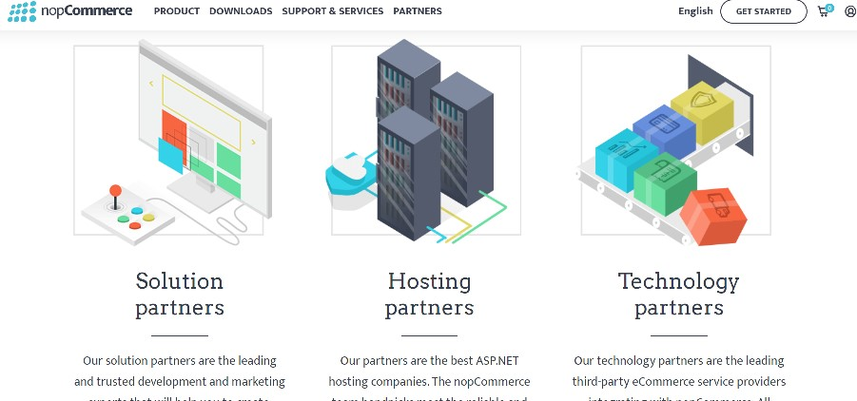

L

i

n

k

:

h

t

t

p

s

:

/

/

w

w

w

.

n

o

p

c

o

m

m

e

r

c

e

.

c

o

m

/

e

n

/

p

a

r

t

n

e

r

s

Verifying each and every button links functionality, upon clicking each link is it navigating to desired links are not.

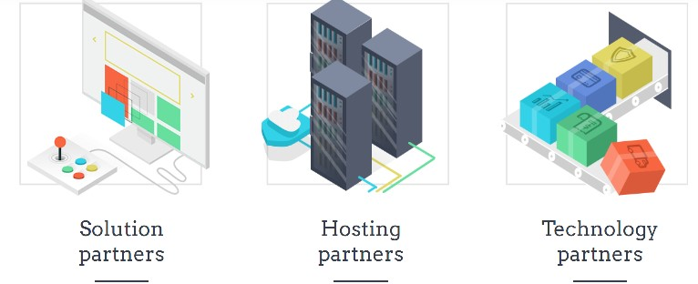

Link: https://www.nopcommerce.com/en/partners

In simple words, when a user clicks on sub module links it has to navigate to desired link and show the desired pages accordingly.

## M

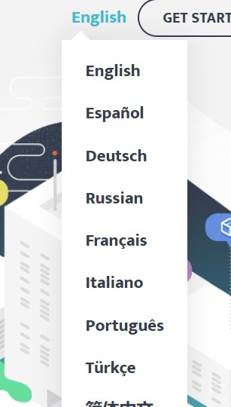

Verify User can change the language from ‘Language ’section.

Link: https://www.nopcommerce.com/en/download-nopcommerce

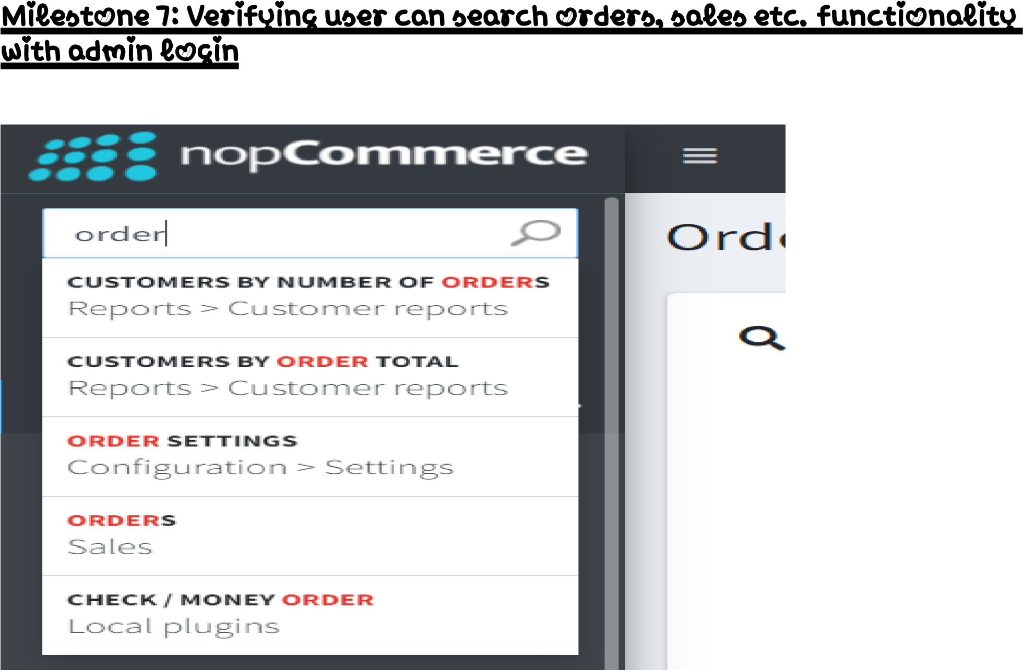

Link: https://admin-demo.nopcommerce.com/admin/

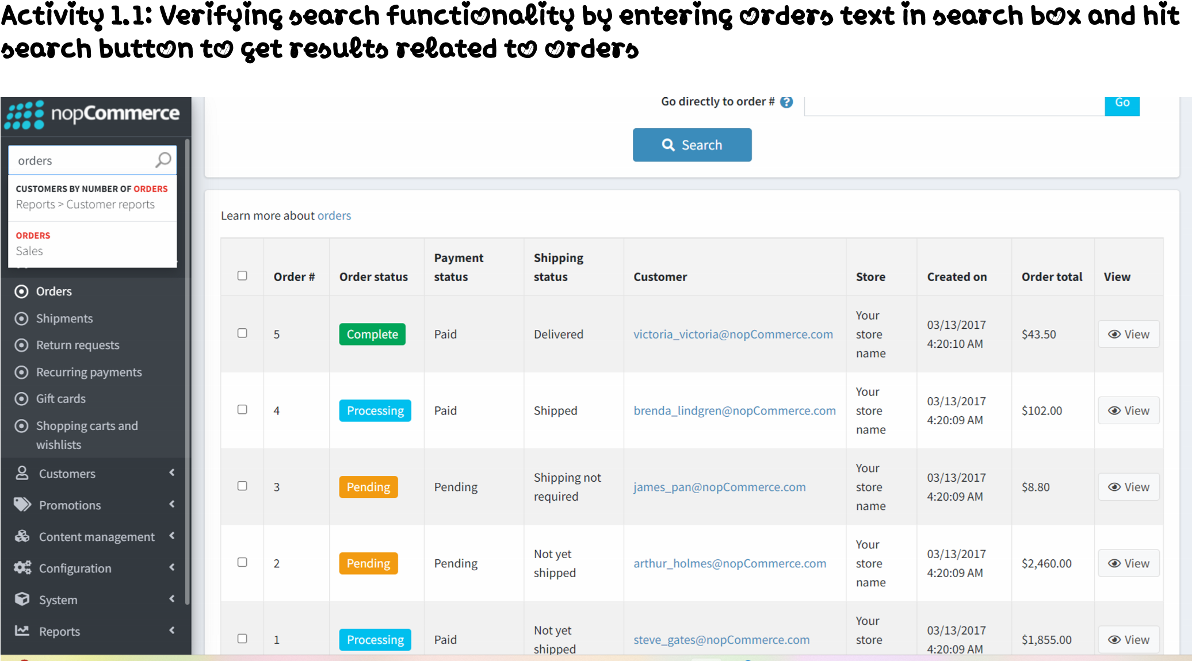

Link: https://admin-demo.nopcommerce.com/admin/



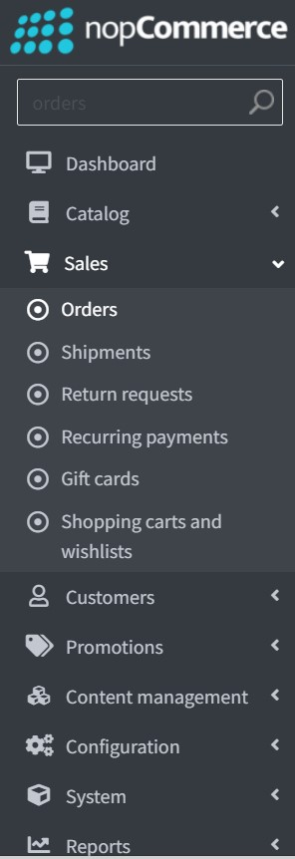

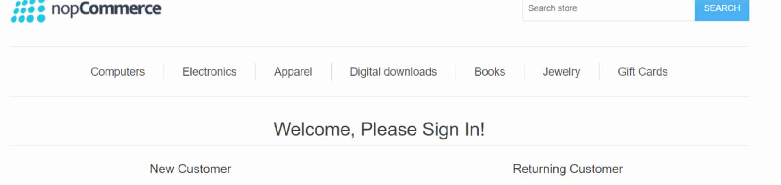Link: <https://admin-demo.nopcommerce.com/admin>

Link: https://demo.nopcommerce.com/login?returnUrl=%2F

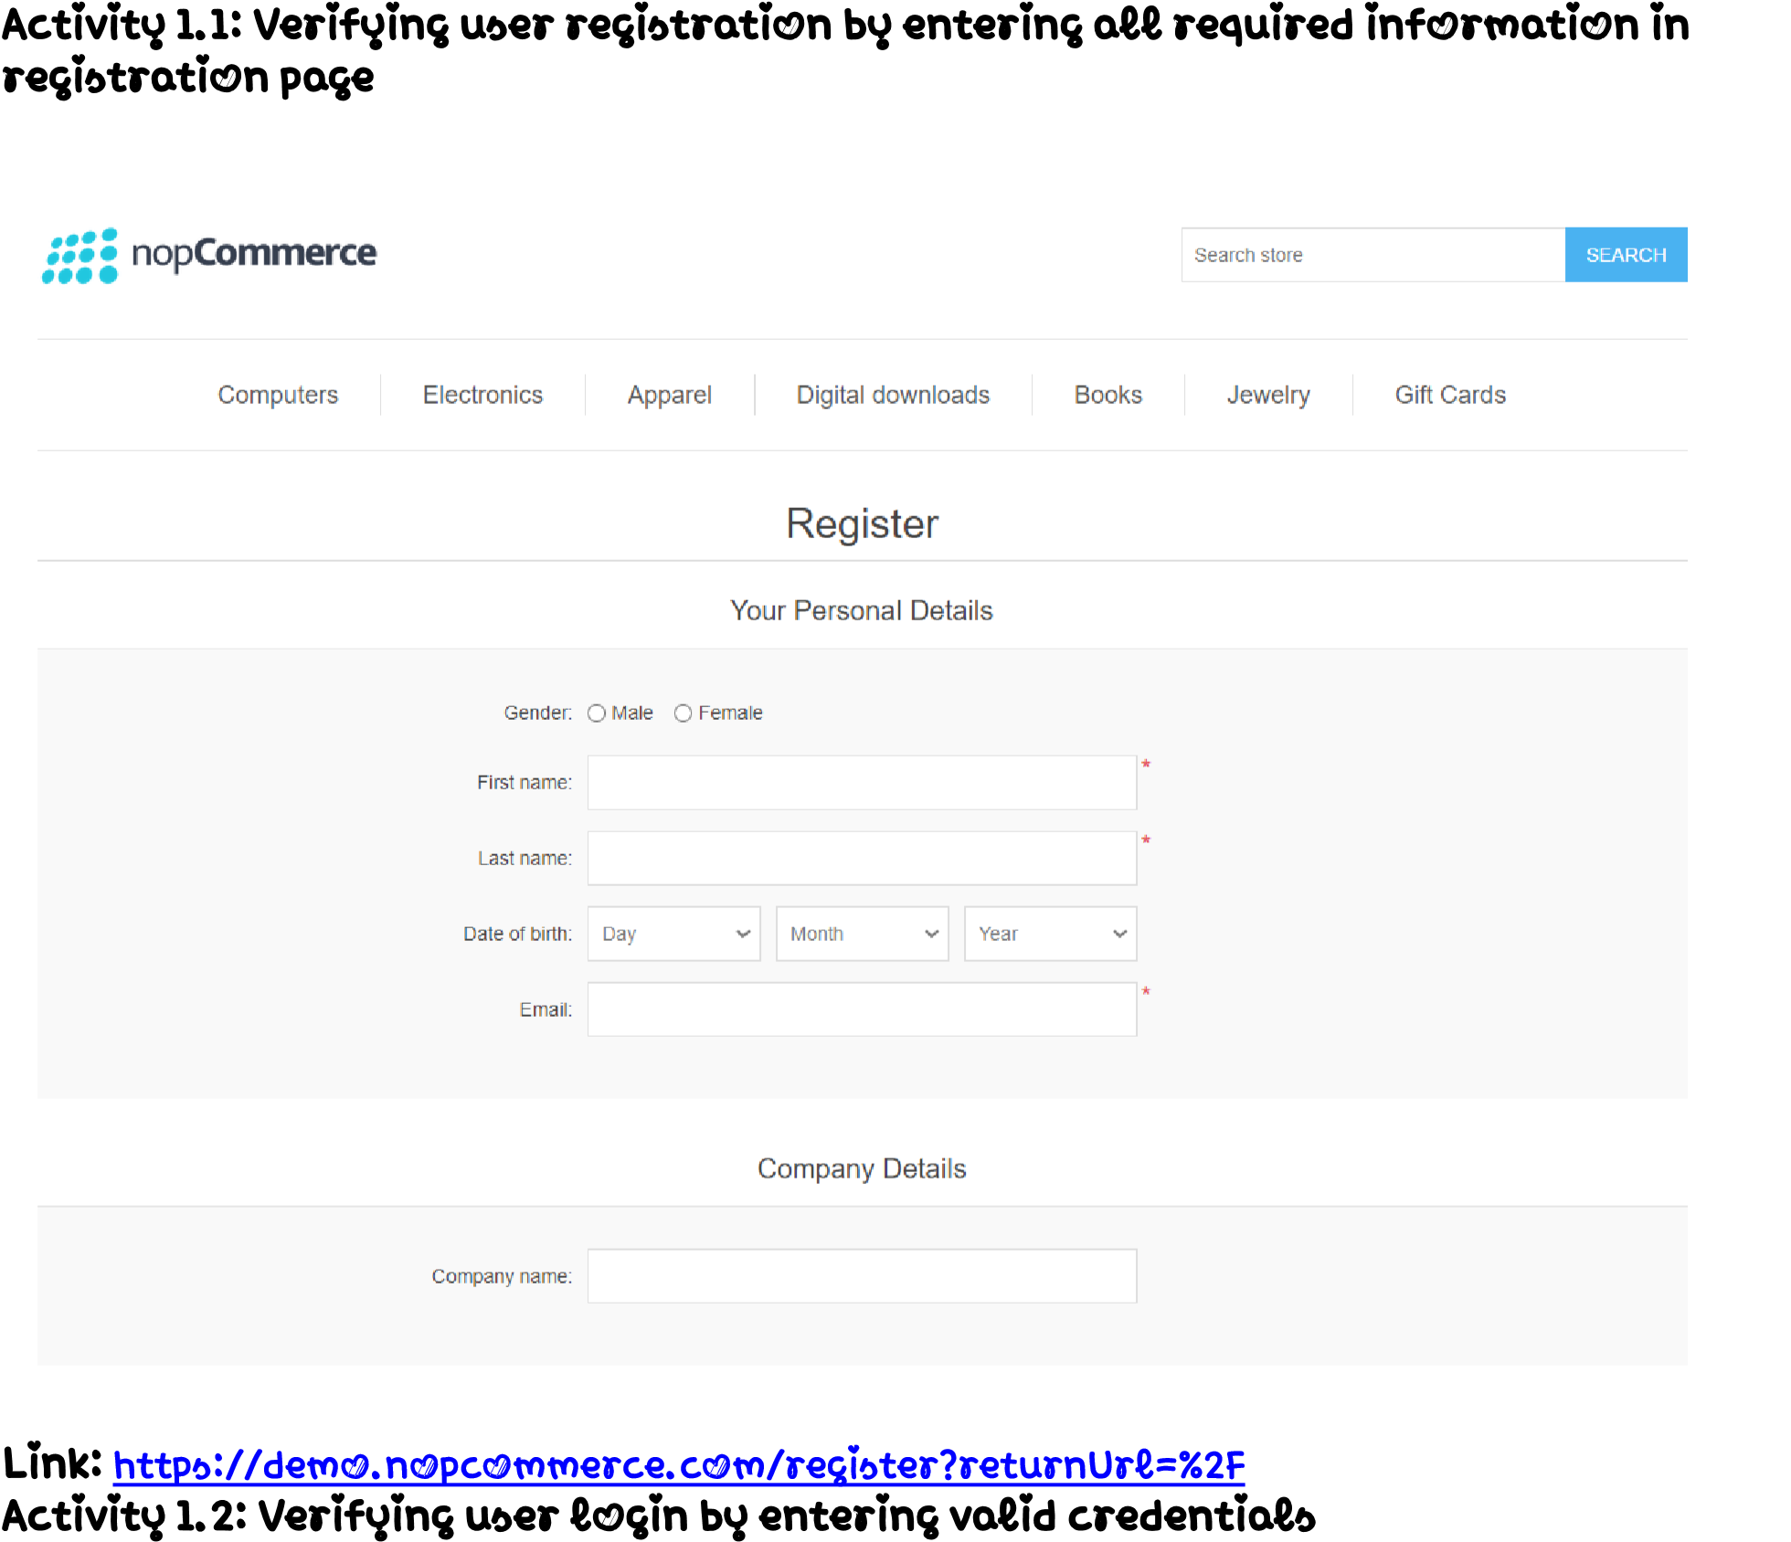

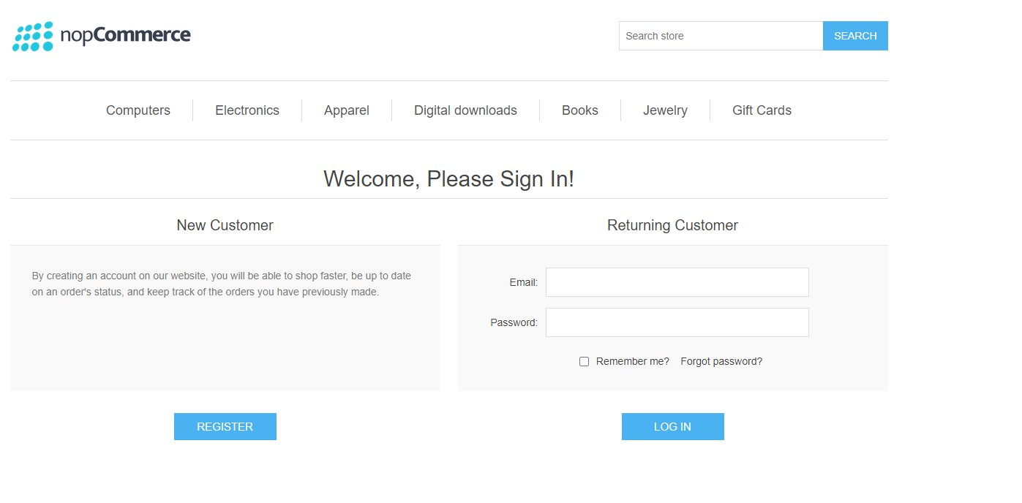

Link: https://demo.nopcommerce.com/login?returnUrl=%2F

1. Test the Home page elements color, font, alignment, design
2. Test the admin area login functionality
3. Test the Front-end login functionality
4. Test get started button functionality
5. Test the user can enter valid email & password
6. Test the user can enter invalid email & password
7. Test the main modules and sub modules functionality
8. Test user can search from global search area after login as an admin
9. Test sub modules pages are loading properly or not
10. Test user can logout successfully





Automation Testing nopCommerce

Project based experience learning program

# 

nopCommerce is the best open-source eCommerce shopping cart solution. nopCommerce is free, and it is the most popular ASP.NET eCommerce platform. The first nopCommerce version was released in 2008. At that time there were no free and open-source shopping carts that would not impose the limitations on business processes and flow hence the essential goal for nopCommerce was to fix that.

The high quality of the product and its constant development led to creating the global nopCommerce community of over 250,000 members. The philosophy of the open-source product allows us to receive the contribution of developers and businesses from around the world. That helps us to grow faster and meet the highest security and technology standards.

* Introduction • Project Overview • Getting Started • Prerequisites • Installation • Project Setup • Project Structure • Writing Test Cases • Running Tests
* Test Reporting • Troubleshooting

# • Conclusion Introduction

The nopCommerce project is a Python automation project that utilizes the Selenium framework for automating web interactions. This documentation provides an overview of the project, instructions for installation and configuration, details about the project structure, and examples of test cases.

The nopCommerce project aims to automate various tasks on the Bluestone website. It leverages Selenium, a powerful web automation tool, to interact with web elements and perform actions such as clicking buttons, filling forms, and extracting data.

Explain the prerequisites and setup required to run the project.

Before getting started with the nopCommerce project, ensure you have the following prerequisites:

List the software and tools that need to be installed before running the project, such as:

To install the necessary dependencies for the nopCommerce automation project, follow these steps:

Activity 2.1:~~-~~Install Python: Visit the Python website (https://www.python.org) and download the latest version of Python. Follow the installation instructions for your operating system.

A

c

t

i

v

i

t

y

2

.

2

~~:~~

~~-~~

D

o

w

n

l

o

a

d

a

n

d

i

n

s

t

a

l

l

g

i

t

b

a

s

h

f

r

o

m

h

t

t

p

s

:

/

/

g

i

t

-

s

c

m

.

c

o

m

/

d

o

w

n

l

o

a

d

/

w

i

n

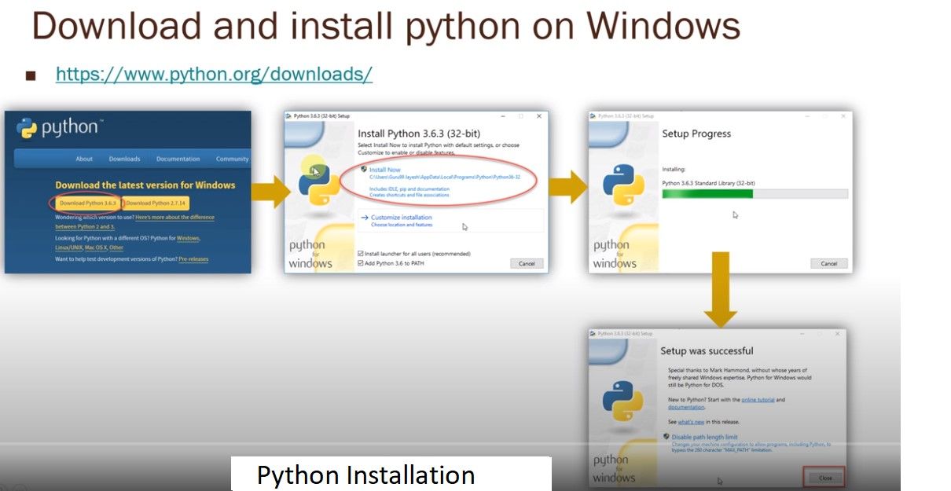

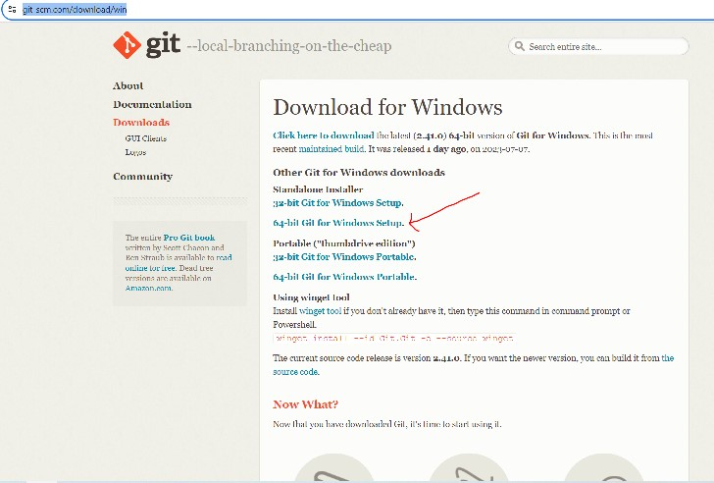

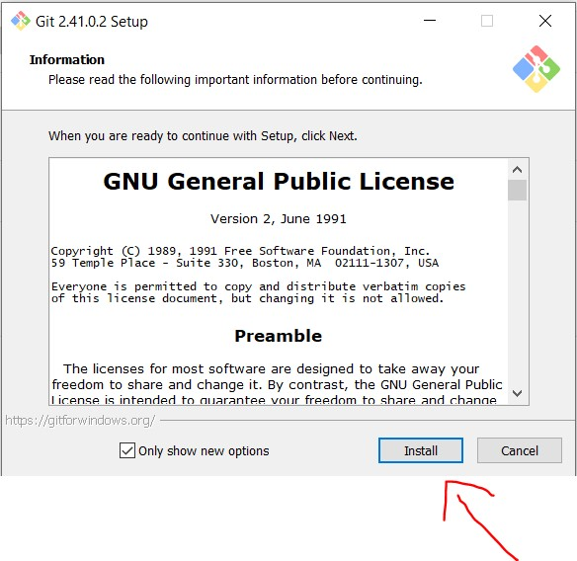

A

c

t

i

v

i

t

y

2

.

3

~~:~~

~~-~~

Go to the desired location where you want to create the folder, such as Desktop.

Folder name like eg…(Automation_Testing_Project)

Open the folder-→ Right click with in the folder and select open gitbash here, you will get pop up like below and clone the repository based on the next steps provided below.

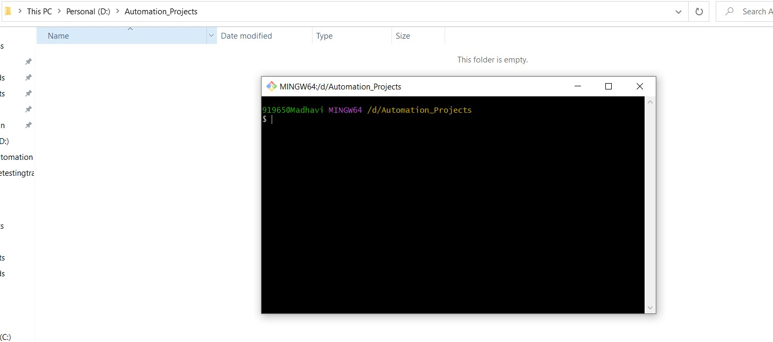

A

c

t

i

v

i

t

y

3

~~:~~

~~-~~

P

r

o

j

e

c

t

S

e

t

u

p

Explained how to set up the project locally, including steps like:

Clone the repository from github.

. Clone the nopCommerce project repository from [repository URL].

https://github.com/viswatesting123/SmartBridge_Automation_Projects.gi t

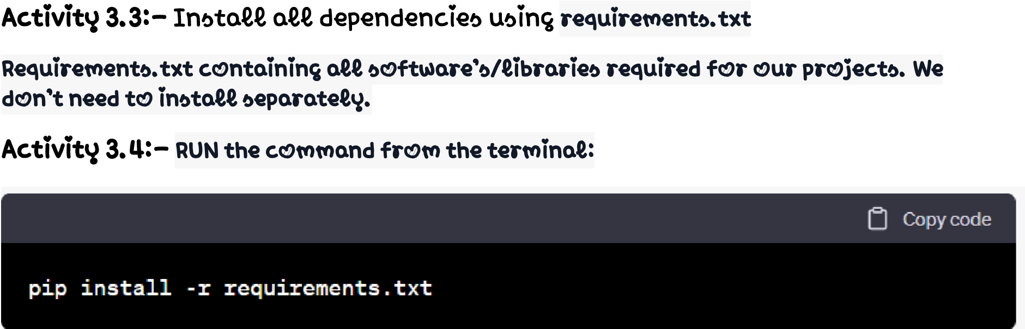

~~-~~Explained the structure of the project, including directories and files, and their purposes. For example:

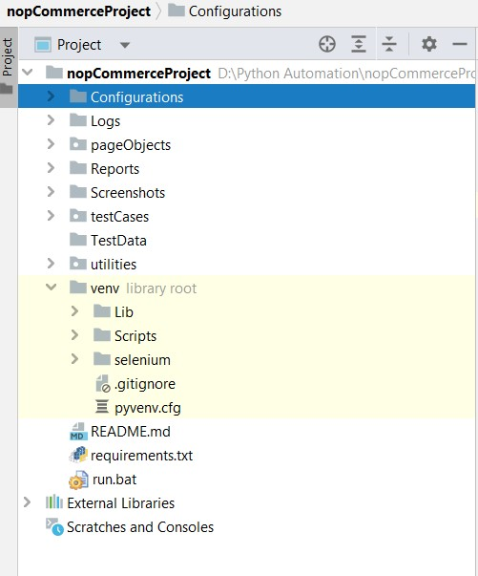

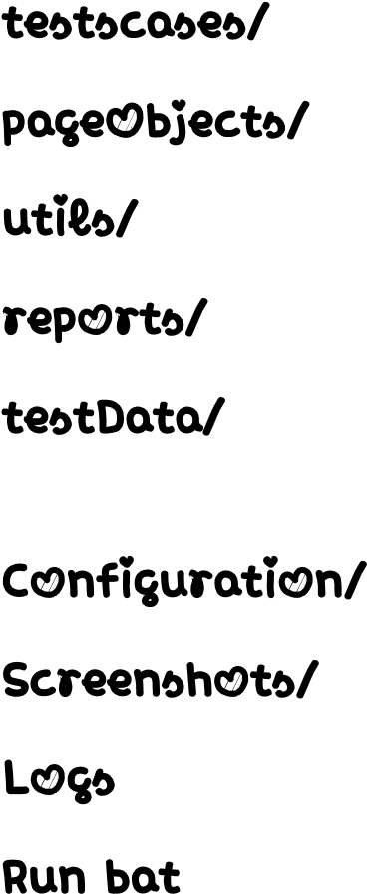 : Directory containing test scripts

* Directory containing page object models
* U : Directory containing utility functions

:Directory containing test reports

* : Directory containing test data (ex:excel,csv,text,json files) related to project

file for storing settings

: Project testcases screenshots.

* /: Directory maintain the project logs.
* /: Now, you can double-click the run.bat file to execute the Python script specified in the command. The script will run in a Command Prompt window.

Explained how to write test cases using Python, Selenium, and pytest. Provide examples of different types of test cases, such as: • Test case 1: Home Page functionality Screenshot of the code:

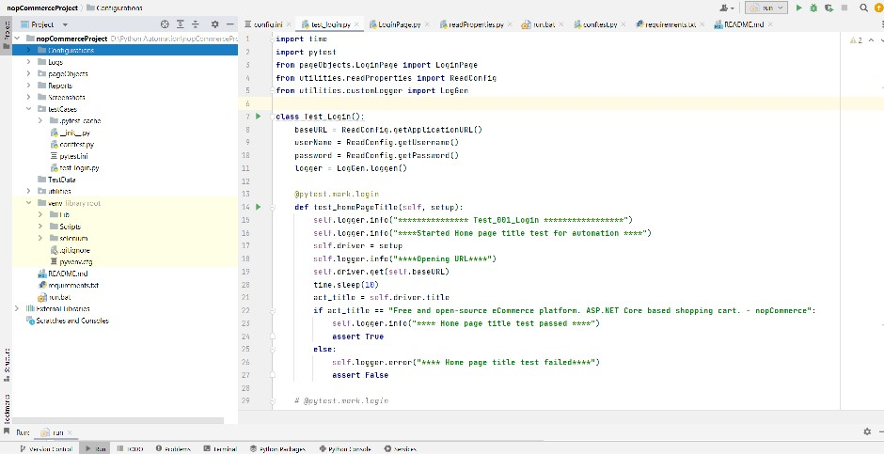

* Test case 2: Register new user functionality

Include best practices for writing maintainable and readable test cases.

Explained how to run the test cases using pytest. Include information about command-line options and flags that can be used to customize test execution.

Activity 1:~~-~~ Run.bat/: Now, you can double-click the run.bat file to execute the Python script specified in the command. The script will run in a Command Prompt window.

Explained how test reports are generated and where they are stored. Include information about any tools or libraries used for reporting, such as pytesthtml.

: Directory containing test reports

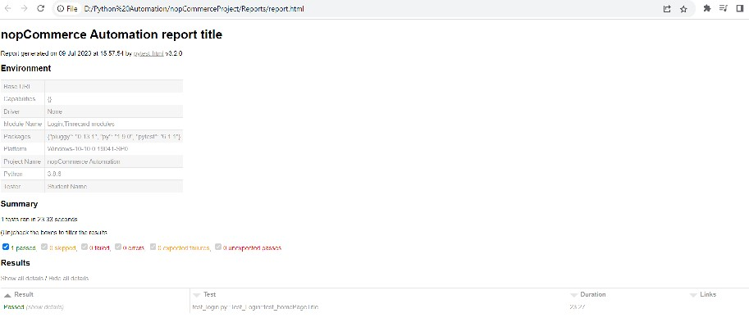

List common issues that may occur during project setup or test execution and provide possible solutions.

The automation project provides a framework for automating various tasks within the nopCommerce web application using Python, Selenium, and Pytest. With this documentation, you should be able to set up the project, execute tests, and extend/customize it according to your needs.